Muhammad jawad
Roll No 233557
BSCS A

Library Management System

Book Entry Form:
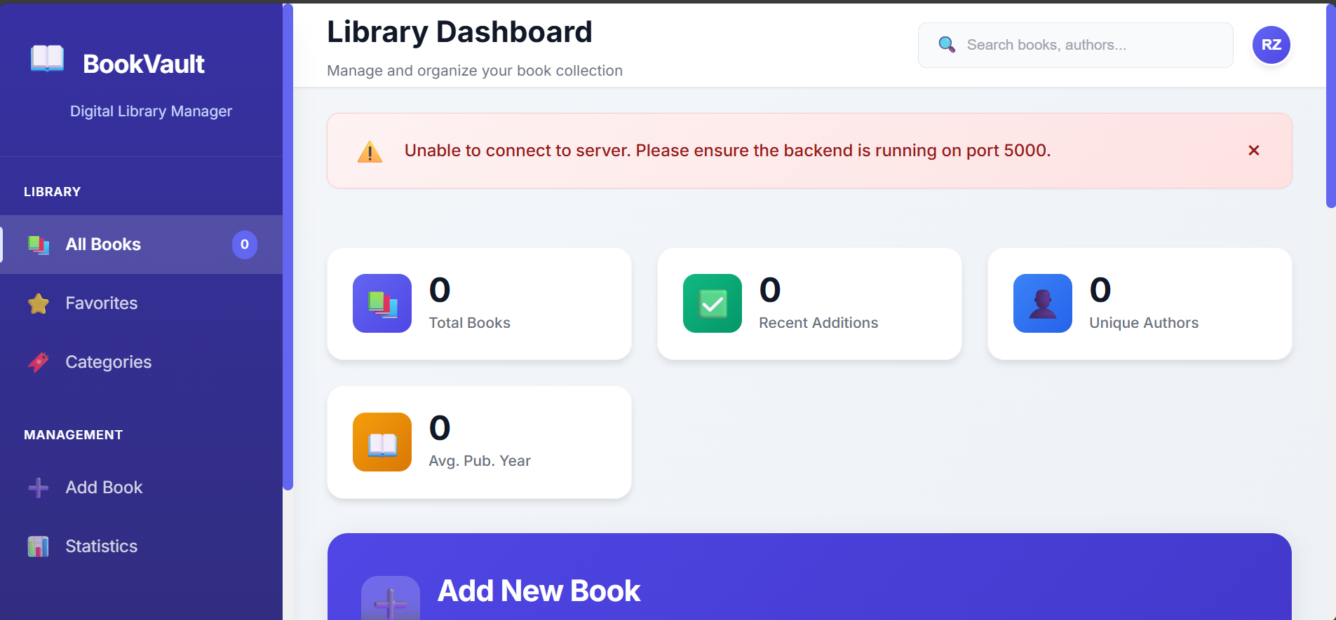
Books Collections:


Add Book :
